

**PRINCIPLES OF MEASUREMENT AND SENSORS**

**END SEMESTER PROJECT**

**TEAM MEMBERS:**

|  |  |
| --- | --- |
| AM.EN.U4AIE21002 | Abhishek Ashok Kumar |
| AM.EN.U4AIE21023 | Guru Aswini Dath |
| AM.EN.U4AIE21027 | Eric Oommen Mathew |
| AM.EN.U4AIE21043 | Manav Maniprasad |
| AM.EN.U4AIE21071 | Anupa Sajikumar |
| AM.EN.U4AIE21082 | Vishnujith Manu |

1. *Soil moisture sensor*

*Contents:*

Introduction

The soil moisture sensor is one kind of sensor used to gauge the volumetric content of water within the soil. These sensors measure the volumetric water content not directly .These sensors normally used to check volumetric water content, and another group of sensors calculates a new property of moisture within soils named water potential. Generally, these sensors are named as soil water potential sensors which include gypsum blocks and tensiometer.

Applications

* Agriculture
* Landscape irrigation
* Research
* Simple sensors for gardeners

Circuit Diagram

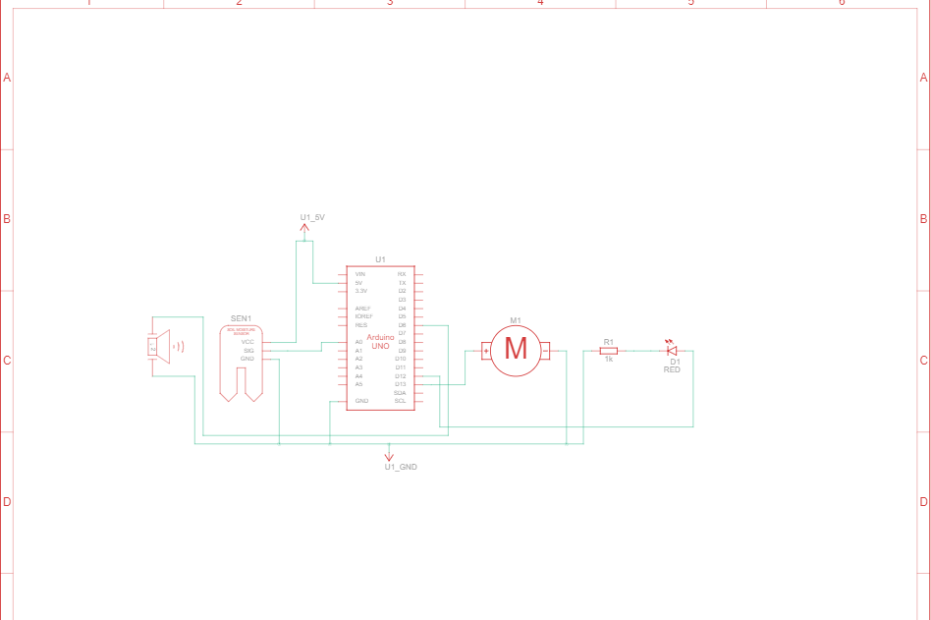

**B)Tank Level Control System**

Tank Level Control System is a system specifically designed to control the level of water in tanks. The main aim possessed by these systems is to control the rate with which the pump delivers water to the tank and so it can reach the desired level inside the tank.

The purpose of the Tank level system is to maintain a specific level of water inside the tank.

**Advantage:**

Adjustable on/off level control allows the level settings to be altered without shutting down the process.

**Disadvantage:**

More expensive than non-adjustable on/off control.

**Applications:**

Can be used for most liquids, including those with low conductivities.

**Sensors used in This project:**

**Soil Moisture Sensor**

The Soil Moisture Sensor uses capacitance to measure dielectric permittivity of the surrounding medium. In soil, dielectric permittivity is a function of the water content. The sensor creates a voltage proportional to the dielectric permittivity, and therefore the water content of the soil.

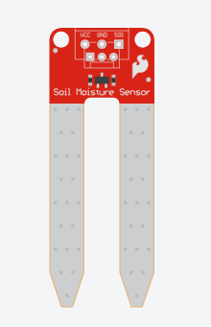

**Ultra Sonic Sensor:**

An ultrasonic sensor is an electronic device that measures the distance of a target object by emitting ultrasonic sound waves, and converts the reflected sound into an electrical signal. Ultrasonic waves travel faster than the speed of audible sound (i.e. the sound that humans can hear). Ultrasonic sensors have two main components: the transmitter (which emits the sound using piezoelectric crystals) and the receiver (which encounters the sound after it has travelled to and from the target).

